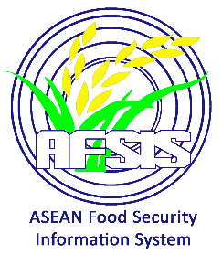
Flooding and Landslides
in Regions X, XI, and CARAGA, Philippines
02 February 2024

Source: ASEAN Disaster Monitoring & Response System (DMRS), ASEAN Disaster Information Network (ADINet); Pacific Disaster Center (PDC Global); ASEAN Specialized Meteorological Centre (ASMC)

References:
- https://ahacentre.org/flash-update/flash-update-no-01-flooding-and-landslides-in-regions-x-xi-and-caraga-philippines-2-february-2024/
- https://reliefweb.int/report/philippines/philippines-flooding-and-landslides-regions-x-xi-and-caraga-flash-update-1-2-feb-2024-2130-hrs-utc-7
- https://crisis24.garda.com/alerts/2024/01/philippines-adverse-weather-forecast-across-southern-regions-through-at-least-feb-1

The Philippine Atmospheric, Geophysical, and Astronomical Administration (PAGASA)
has issued a weather advisory, cautioning residents to brace for significant rainfall in the affected area
of Caraga and Davao regions. The weather is foreseen in various regions of the southern Philippines
in February 1, 2024.

On February 2, 2024, the island of Mindanao in the Philippines felt the impact of the Northeast Monsoon and the Trough of the Low-Pressure Area (LPA), as disclosed by the National Disaster Risk Reduction and Management Council (NDRRMC). The persistent trough of the Low-Pressure Area led to moderate to heavy rainfall, resulting in flooding and landslides across multiple areas in the region.

The NDRRMC has reported significant consequences from recent adverse weather events. Infrastructure damage has amounted to 1,100 USD, with power outages impacting cities/municipalities
in Philippines. Water supply interruptions persist in two cities/municipalities. The displacement of 188,400 individuals has led to 624,000 seeking shelter in 290 evacuation centers, highlighting the substantial impact on communities in Northern Mindanao region, Davao regions, and Caraga region.

The NDRRMC has issued a memorandum in preparation for the LPA in Mindanao.
The PAGASA actively monitored and played a crucial role in providing early warnings about
the development of weather systems and their potential impacts. Additionally, a substantial aid effort
has been initiated, with 45,600 USD worth of assistance distributed in the form of Family Food Packs
and Food Items to support the affected communities.

